Two-Stage Machine Learning Pipeline for Data Imputation and Anomaly Verification in SME Carbon Accounting
Abstract
The credibility of facility-level carbon accounting rests on the assumption that energy telemetry from manufacturing sites faithfully reflects physical operations. This assumption is fragile for small and medium-sized enterprises (SMEs) in emerging economies, where heterogeneous sensors, frequent data loss, and financial incentives for misreporting produce data quality challenges that current IoT-based Measurement, Reporting, and Verification (MRV) architectures cannot detect. A two-stage machine-learning pipeline is proposed targeting the unaddressed intersection of IoT-based MRV, bidirectional Long Short-Term Memory (BiLSTM) imputation, and autoencoder-based anomaly detection. Stage 1 deploys a BiLSTM to reconstruct missing grid and solar photovoltaic telemetry, with epistemic uncertainty quantified via Monte Carlo Dropout and low-confidence reconstructions flagged rather than silently accepted. Stage 2 deploys an unsupervised autoencoder that learns the latent energy–production coupling and flags structurally anomalous records through reconstruction error, classified by a three-tier taxonomy aligned with regulatory proportionality. The pipeline is validated on a calibrated digital twin of a Tier-2 automotive-parts manufacturer in Thailand's Eastern Economic Corridor, with controlled injection of sensor dropout, drift, and three manipulation sub-types. The BiLSTM is benchmarked against six baselines including SAITS and BRITS: the autoencoder against four baselines including USAD, with Peaks-Over-Threshold calibration. [Results placeholder: BiLSTM achieves R² = X.XX; autoencoder detects Y% of manipulation at F1 = Z.ZZ; integrated pipeline reduces monthly tCO₂e deviation from A% to B%.] While real-world validation remains necessary, the findings suggest that sensor deployment alone is insufficient for SME cleaner production; a software-layer verification mechanism is required before emissions data enter carbon markets or sustainability-linked lending covenants.
Keywords: Digital MRV; Carbon accounting integrity; Bidirectional LSTM imputation; Autoencoder anomaly detection; SME decarbonization; Digital twin.
1. Introduction
The credibility of global climate action, and of the cleaner-production agenda that this journal foregrounds, rests on an assumption that has received less scrutiny than the policies it underwrites that the emissions reported by industrial facilities accurately reflect their physical operations. Measurement, Reporting, and Verification (MRV) systems are the evidentiary backbone of carbon pricing, Nationally Determined Contributions, and the rapidly expanding sustainable-finance ecosystem. Yet the integrity of these systems is fragile where it matters most — at the facility level. Recent syntheses indicate that fewer than 16% of issued carbon credits corresponded to real emission reductions across more than 2,300 reviewed projects (Romm et al., 2025), consistent with earlier documentation of systematic discrepancies in the EU Emissions Trading System and the Clean Development Mechanism (Schneider and La Hoz Theuer, 2019; Duflo et al., 2013). These findings raise a specific and operational question: whether carbon markets and sustainability-linked instruments are pricing real abatement or accounting artefacts.
Building on this credibility problem, the locus of vulnerability is particularly acute for small and medium-sized enterprises (SMEs) in emerging economies. While large emitters in OECD jurisdictions operate under mature regulatory regimes with third-party verification and continuous emissions monitoring systems (CEMS), most industrial emissions in developing Asia originate from facilities that lack these institutional safeguards. IoT-based monitoring has been proposed as the technological leapfrog that would bring facility-level transparency to previously unmonitored sectors (World Bank, 2022; UNFCCC, 2021). However, as Börner et al. (2025) argue in their systematization of digital MRV, the deployment of IoT sensors does not guarantee data integrity; it merely digitizes the point of potential failure.
1.1 The Thai manufacturing context
Turning from the global problem to its instantiation, Thailand offers an instructive and policy-active case. The country's Climate Change Act (2024) establishes the legislative foundation for mandatory emissions reporting and a domestic carbon-pricing mechanism. The Department of Industrial Works (DIW) operates a CEMS reporting framework that will progressively extend coverage from large point-source emitters to smaller industrial facilities, including the Tier-2 heavy manufacturing SMEs automotive-parts fabrication, CNC machining, metal stamping concentrated along the Eastern Economic Corridor (EEC). In parallel, the Thailand Greenhouse Gas Management Organization (TGO) administers the Thailand Voluntary Emission Reduction Program (T-VER) and the Carbon Footprint for Organization (CFO) scheme, both of which rely on self-reported facility data.
These Tier-2 SMEs occupy a structural blind spot in the Thai compliance architecture. They are large enough to generate material emissions typically 500–15,000 tCO₂e annually but too small to justify industrial-grade CEMS capital expenditure or dedicated environmental compliance staff. Their energy systems are characteristically heterogeneous: grid electricity from the Provincial Electricity Authority (PEA), distributed solar photovoltaic (PV) generation, diesel backup, and production output logged through a patchwork of manufacturing execution systems (MES), manual entry, and legacy SCADA interfaces. The result is a data environment defined by incompleteness, inconsistency, and opacity precisely the conditions under which data manipulation is both easiest to commit and hardest to detect.
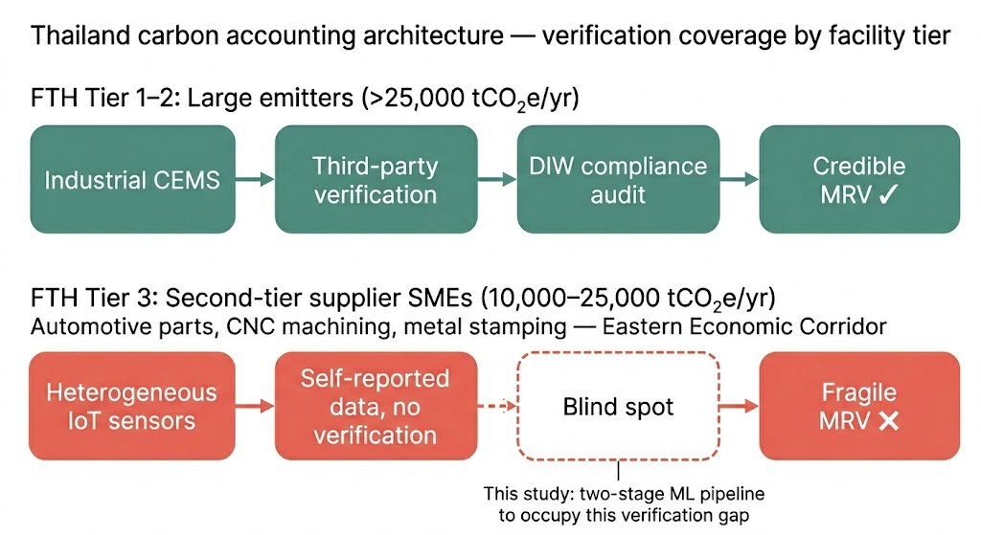
1.2 The "dirty data" problem in factory telemetry
Against this institutional backdrop, the specific technical problem addressed by this study is the systematic unreliability of SME energy telemetry. Three categories of data degradation recur in practice. The first is sensor dropout: Wi-Fi instability, power transients during load switching, and hardware degradation produce contiguous gaps ranging from minutes to days. Monthly emissions reports with even 5% data loss are extrapolations whose bias direction and magnitude are unknown. The second is temporal misalignment: grid meters, solar-inverter loggers, and production counters typically operate at different sampling frequencies and are not time-synchronized, creating windows where energy inputs and production outputs cannot be coherently matched. The third, and most consequential, is deliberate or negligent data manipulation termed "statistical greenwashing" in what follows. A facility seeking to demonstrate emissions reductions for carbon-credit eligibility, regulatory compliance, or sustainability-linked loan (SLL) covenants has a direct financial incentive to report data that flatters its carbon intensity. In the absence of an integrity-verification layer, the MRV system functions as a trust-based ledger with no audit mechanism.
Beyond regulatory compliance, this trust gap is increasingly a binding constraint on access to green finance instruments. Sustainability-linked loans and CBAM-readiness financing now require periodic KPI verification against auditable baselines verification that current dMRV architectures cannot deliver when the underlying telemetry is incomplete or unauditable (Börner et al., 2025; S&P Global, 2024).
Current approaches to this problem are inadequate. IoT-based MRV implicitly treats sensor data, once digitised, as trustworthy; monitoring infrastructure is designed as a transparent pipe rather than as a potential source of systematic error. When gaps occur, standard practice employs simple statistical imputation (linear interpolation, mean substitution) that preserves summary statistics but destroys the temporal structure necessary for manipulation detection. As Niako et al. (2024) show, imputation method selection materially alters downstream model accuracy a finding that translates directly into tCO₂e reporting error. Critically, no existing MRV framework incorporates a machine-learning verification layer capable of distinguishing legitimate operational variance from records that are physically inconsistent with observed energy–production relationships.
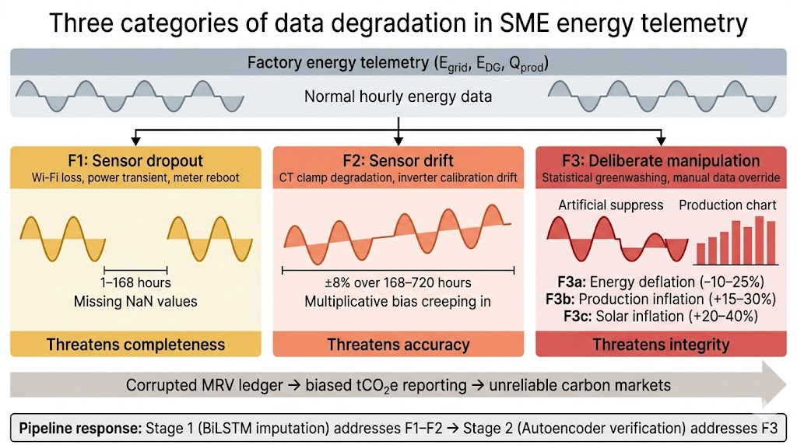
1.3 Research gap, hypotheses, and contribution to cleaner production
Synthesizing the above, this study targets the unoccupied intersection of three established streams. IoT-based MRV research has concentrated on sensor-deployment architectures and data-transmission protocols (Gao et al., 2024; Fay et al., 2024) without interrogating what happens when collected data are incomplete or compromised. LSTM energy time-series research has concentrated on forward-looking forecasting (Wang et al., 2024), leaving retrospective compliance reconstruction — a problem with different error-tolerance requirements — essentially unaddressed. Autoencoder anomaly-detection research in manufacturing has concentrated on predictive equipment maintenance and cybersecurity, as in Alfeo et al. (2020) and Kaymakci et al. (2021), where the anomaly of interest is a mechanical fault or cyber-physical attack rather than a violation of physical consistency in a carbon-accounting record.
Two falsifiable hypotheses are proposed:
- H1 (Imputation). A BiLSTM imputation engine trained on clean facility telemetry reconstructs missing grid and solar PV readings with lower bias and RMSE than linear, LOCF, mean-substitution, and k-NN baselines, and its degradation with gap length remains bounded such that short (1–12 h) and medium (12–48 h) gaps introduce < 1% bias into monthly tCO₂e totals.
- H2 (Verification). Autoencoder reconstruction error, trained on normal energy–production coupling, discriminates deliberate manipulation (F3a/b/c) from legitimate operational variance with F1 > 0.80 at a false-positive rate ≤ 2%, and this detection performance is preserved when the autoencoder is applied to BiLSTM-imputed rather than ground-truth inputs.
The cleaner-production contribution and the reason this manuscript belongs in Journal of Cleaner Production rather than a general ML venue is threefold. First, the pipeline makes credible SME carbon accounting operationally feasible at a data-quality tier where it is currently unachievable, removing a binding constraint on SME participation in carbon pricing and green-finance mechanisms. Second, the three-tier anomaly taxonomy furnishes a proportionate regulatory response framework that scales enforcement effort with deviation severity, consistent with the proportionality principle embedded in the DIW CEMS framework. Third, the digital-twin and fault-injection protocol is reproducible and transferable to other Tier-2 manufacturing archetypes in emerging Asia, enabling cross-facility cleaner-production benchmarking without requiring access to proprietary factory telemetry.
1.4 Scope and delimitations
The study is deliberately scoped. The target population is Tier-2 heavy manufacturing SMEs (automotive parts, CNC machining) on the EEC, operating on PEA grid electricity and on-site solar PV. Three telemetry streams are modelled at hourly resolution over a 12-month synthetic period: grid energy (E_grid), solar PV generation (E_DG), and production throughput (Q_prod). The digital twin is calibrated against published Thai industrial load profiles and solar-irradiance data for the Rayong–Chonburi corridor.
Scope 2 market-based accounting and Scope 3 supply-chain emissions lie outside the boundary. Scope 3 is excluded because supply-chain emissions depend on upstream producers outside the SME's operational control and require a fundamentally different data architecture supply-chain graph rather than facility telemetry, consistent with GHG Protocol (2024) guidance on Scope 3 inventory quality. Financial algorithms for SLL pricing or carbon-credit valuation are likewise excluded; the link to green finance is discussed as motivation and downstream application context, not as a methodological contribution. The pipeline operates in retrospective batch mode on completed reporting periods; real-time streaming deployment is architecturally feasible but is neither implemented nor evaluated here.
2. Literature review
2.1 IoT-based MRV and the unexamined trust assumption
The deployment of IoT infrastructure for monitoring emissions is among the most consequential developments in climate-governance technology of the past decade. Gao et al. (2024) demonstrate that combining IoT sensor networks with blockchain-based verification can compress verification timescales from months to near-real-time; Fay et al. (2024) show that even resource-constrained microcontroller nodes can perform meaningful CO₂-event classification in the field. What both strands share, however, is an unexamined assumption: that once data are digitised, they are trustworthy. IoT-MRV architectures are engineered as transparent pipes — they transmit, aggregate, and display sensor readings, but they do not interrogate the physical plausibility of those readings.
Two strands of empirical evidence indicate that this assumption is unsafe. On the data-integrity side, Romm et al. (2025) synthesise more than 2,300 mitigation projects and find that fewer than 16% of issued credits corresponded to real reductions, a failure whose root causes include, but are not limited to, sensor-level data weakness. On the fraud-enforcement side, the 2024 CQC carbon-credit prosecution, cited by Szabo et al. (2024) in their review of AI-assisted greenwashing detection, confirms that manipulation is no longer a theoretical risk. Xu et al. (2023) take a step toward addressing this gap by deploying ML-based outlier scoring for ETS verification of listed facilities, demonstrating that automated anomaly detection can double the detection rate under a fixed audit budget; however, their approach operates as a single-stage screening tool for large emitters and does not incorporate data imputation or target the SME context where data quality problems are most acute. A counterargument could be raised that these findings concern project-level additionality and baseline inflation rather than facility-sensor manipulation; the rebuttal is that both failure modes propagate through the same MRV pipeline and are therefore unobservable to any architecture that does not interrogate the data itself. What is still absent from the IoT-MRV literature is a verification layer that operates inside the pipeline — a software mechanism capable of assessing whether reported energy and production data are physically consistent before they are accepted into the carbon-accounting ledger.
2.2 LSTM networks for energy time-series: forecast versus retrospective reconstruction
Recurrent gated architectures, introduced by Hochreiter and Schmidhuber (1997), have become dominant for energy time-series analysis, and the literature on their forecasting applications is extensive. Wang et al. (2024) survey AI-empowered methods for smart energy consumption and confirm that LSTM architectures consistently outperform statistical models for short-term load forecasting under high demand variability. Parallel work has expanded LSTM applications to missing-data imputation: Fan et al. (2020) propose a bidirectional LSTM with transfer learning (LSTM-BIT) for building energy data and show that deep-learning imputation substantially outperforms linear and mean-substitution baselines even at 90% data loss. Müller et al. (2023) apply attention-based imputation to European grid data, Zhang et al. (2025) combine LSTM with variational autoencoders and transfer learning, and Galdelli et al. (2025) introduce a BackForward Bi-LSTM for large spatiotemporal gaps. Niako et al. (2024) establish, on an orthogonal domain, that imputation-method selection measurably affects downstream model accuracy, a result with direct implications for compliance-grade carbon accounting. Che et al. (2018) provide foundational work on recurrent architectures for multivariate time series with missing values, establishing the GRU-D framework that directly informs the decay-based handling of irregular gaps in industrial telemetry.
More recently, attention-based imputation models have advanced the state of the art. Du et al. (2023) propose SAITS (Self-Attention-based Imputation for Time Series), which achieves 12–38% MAE reduction over BRITS (Cao et al., 2018) on benchmark datasets including UCI Electricity; Wang et al. (2025) survey the broader deep-learning imputation landscape in their IJCAI review, cataloguing Transformer, diffusion, and GAN-based approaches. A BiLSTM architecture is nonetheless selected for the present study on the basis of data efficiency: SME-scale datasets (a single facility, 8,760 hourly records) fall below the regime where Transformer-class models demonstrate consistent advantage over recurrent architectures (Fan et al., 2020; Galdelli et al., 2025), and the computational tractability of a two-layer BiLSTM is compatible with the constrained infrastructure typical of Thai SME environments. SAITS and BRITS are retained as baselines in Section 4 to validate this design choice empirically.
Despite this progress, a systematic gap persists in the application context. The LSTM energy-imputation literature targets two scenarios: building-level energy management, where the objective is operational efficiency, and grid-level transmission data, where the scale is national or regional. No published study has applied LSTM-based imputation specifically to the reconstruction of missing factory telemetry for carbon-accounting compliance. This distinction is not cosmetic. Compliance imputation operates under different error-tolerance requirements than operational forecasting: a 5% error in a next-day load forecast is operationally acceptable, whereas a 5% systematic bias in a quarterly emissions report may constitute a material misstatement under regulatory audit (ISO 14064-3 sets the materiality threshold for reasonable assurance at 5%). Compliance imputation is also inherently retrospective, which makes bidirectional architectures admissible and reframes the primary evaluation metric from RMSE to bias.
2.3 Autoencoder-based anomaly detection: predictive maintenance versus carbon-ledger integrity
Autoencoders, neural networks trained to reconstruct their input through a compressed latent representation — have emerged as a leading unsupervised approach for anomaly detection in industrial control. The operating principle is concise: the network learns to reconstruct normal patterns; inputs that deviate from the learned manifold produce elevated reconstruction error. Kaymakci et al. (2021) present the closest published precedent to the present work: an LSTM-autoencoder for energy-anomaly detection in industrial manufacturing. Their system identifies anomalous consumption patterns without labelled training data, but its objective is energy-waste reduction rather than emissions-reporting integrity, and its anomaly definition is univariate energy consumption relative to expected baseline and does not incorporate the cross-variable coupling between energy input and production output that is essential for detecting manipulation in carbon accounting.
Extending this line of work, Alfeo et al. (2020) propose a general-purpose autoencoder anomaly framework for smart manufacturing, validated on industrial laundry and bearing-vibration data; their architecture performs competitively against isolation-forest baselines, but the anomaly taxonomy remains equipment-level. Kim et al. (2024) advance the multi-source anomaly detection paradigm with a correlation-driven framework that explicitly models inter-variable dependencies across multiple energy sources, achieving precision 0.85 and recall 0.80 with an 18% reduction in false positives through cross-source correlation modelling. Their work is the closest methodological precedent for the energy–production coupling argument in the present study, though it targets building energy management rather than carbon-accounting integrity. In the adjacent domain of industrial control system security, Yang et al. (2021) combine LSTM-autoencoders with multilayer perceptron for false-data-injection detection in smart grids. This smart-grid literature is conceptually adjacent to "statistical greenwashing" detection: both address deliberately falsified data in energy systems. A potential counter-argument is that the required anomaly-detection technology therefore already exists and needs only be ported. The rebuttal is application-specific: smart-grid false-data injection targets cybersecurity threats to grid stability, while carbon-ledger manipulation targets compliance reporting and exploits different degrees of freedom principally the energy–production ratio and cross-channel consistency with irradiance that a utility-stability detector is not designed to police.
The autoencoder landscape has also evolved architecturally. Recent temporal anomaly detectors USAD (Audibert et al., 2020), TranAD (Tuli et al., 2022), and Anomaly Transformer (Xu et al., 2022) incorporate adversarial training, attention mechanisms, or association-discrepancy scoring to improve sensitivity on multivariate time series. A vanilla dense autoencoder is nonetheless adopted in the present study as a deliberate baseline: its interpretability (reconstruction error directly maps to physical-coupling violation) and its low parameter count (compatible with SME-scale data volumes) favor deployment transparency over architectural complexity. USAD is retained as a deep baseline in Section 4 to test whether architectural sophistication yields material detection gains in this specific domain.
The critical gap is therefore the application domain, not the technique. What has not been attempted is the explicit reframing of autoencoder reconstruction error as a carbon-ledger integrity metric, in which the physical coupling between energy consumption and production output is exploited to detect records inconsistent with the thermodynamic constraints governing a manufacturing facility. In predictive maintenance, the anomaly signals a machine fault; in the verification engine proposed here, the anomaly signals a data-integrity violation in the emissions record.
2.4 Digital twins as a controlled-experiment methodology
Digital twins calibrated virtual replicas of physical systems have become established methodology in both energy systems and manufacturing research (Jones et al., 2020; Billey and Wuest, 2024; Abad-Segura et al., 2024). A digital twin is adopted here because it enables controlled ground-truth experimentation unavailable with real factory data: known fault patterns are injected at controlled magnitudes, and the ML pipeline is benchmarked against known ground truth. This methodological choice is defensible given the practical barriers to SME telemetry access in Thailand confidentiality, absent data-sharing protocols, heterogeneous digitization. A reviewer may object that a synthetic testbed inflates reported performance relative to field conditions. The rebuttal is that the twin is a prerequisite for rigorous algorithmic development, not a substitute for field validation; the Limitations section (§5.4.3) accordingly interprets results as upper-bound estimates, and Section 6 identifies real-world validation as the next research step.
2.5 Research-gap synthesis
The three literature pillars are mapped to the specific gap addressed here in Table 1. Table 1 also positions the present study against the nearest competitors: Xu et al. (2023), who deploy ML outlier scoring for ETS verification but without imputation and only for listed facilities; Kim et al. (2024), who model cross-source energy correlation but for building management rather than carbon-ledger integrity; and the Kaymakci et al. (2021) LSTM-autoencoder, which targets energy waste rather than emissions compliance. The intersection of these gaps’ joint imputation-plus-verification, SME scale, developing-economy regulatory context, and explicit mapping to ISO 14064-3 materiality thresholds defines the contribution space of this paper. Individually, each pillar is well-established, but their integration into a unified pipeline purpose-built for carbon-accounting integrity in the SME manufacturing context has not been attempted.
Table 1. Literature gap synthesis and competitive positioning.
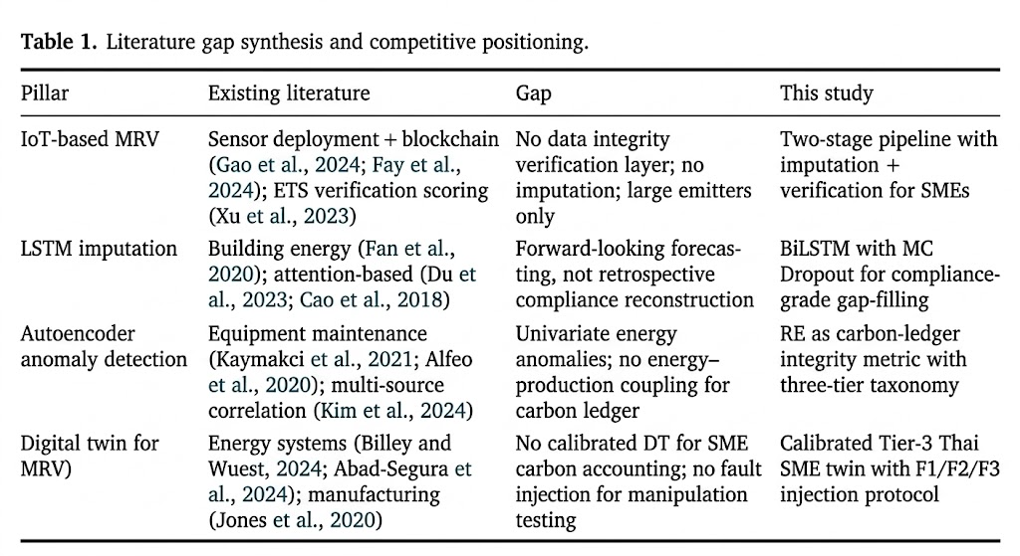
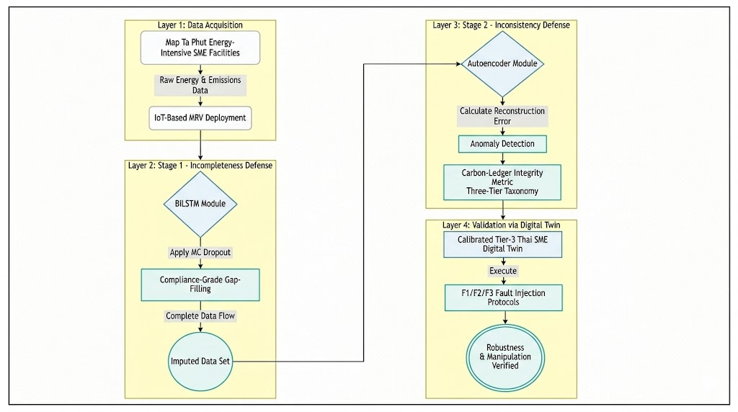

3. Digital Twin Design and Calibration
The digital twin replicates the energy balance and production dynamics of a representative Tier-2 heavy manufacturing SME (automotive-parts fabrication with CNC machining) on Thailand's Eastern Seaboard, within the Rayong–Chonburi corridor of the EEC. It generates three primary telemetry streams at hourly resolution over 12 months: grid electricity consumption (E_grid), on-site solar PV generation (E_DG), and production throughput (Q_prod), with ambient temperature (T_amb) and global horizontal irradiance (GHI) as exogenous inputs.
The twin is implemented in Python 3.11 using NumPy 1.25, Pandas 2.1, and pvlib 0.10, following a modular architecture comprising four subsystems: (i) the factory energy balance model, (ii) the solar PV generation model, (iii) the production schedule model, and (iv) the fault injection protocol.
3.1 Factory energy balance model
The factory’s total electrical energy consumption at each timestep t is modelled as the sum of three components:
$$E_{total\left(t\right)}= E_{base\left(t\right)}+ E_{prod\left(t\right)}+ E_{aux\left(t\right)}$$
where Ebase(t) is the baseline facility load (lighting, HVAC, compressed air systems, office equipment), Eprod(t) is the production-dependent load (CNC spindle motors, hydraulic presses, material handling), and Eaux(t) captures auxiliary and stochastic loads (coolant pumps, dust extraction, intermittent maintenance equipment).
3.1.1 Baseline load
The baseline load follows a deterministic diurnal profile modulated by ambient temperature:
$$E_{base\left(t\right)}= P_{base}× \left[1 + α_{HVAC}×\max\left(0, T_{amb\left(t\right)}- T_{set}\right)\right]+ ε_{base\left(t\right)}$$
where $P_{base}$is the nominal baseline power draw (set at 85 kW based on published Thai industrial facility profiles for automotive parts manufacturers in the EEC), $α_{HVAC}$ = 0.025 kW/°C is the HVAC temperature sensitivity coefficient, $T_{set}$ = 25°C is the cooling setpoint, and $ε_{base\left(t\right)}$~ N(0, 3.5²) kW represents stochastic variation from equipment cycling and occupancy fluctuations. The baseline load is reduced to 35% of nominal during non-production hours (22:00–06:00) and to 15% during weekends and Thai public holidays, reflecting the facility’s security lighting, refrigeration, and standby equipment loads.
Table 2. Digital twin facility parameters for representative Tier-2 SME.
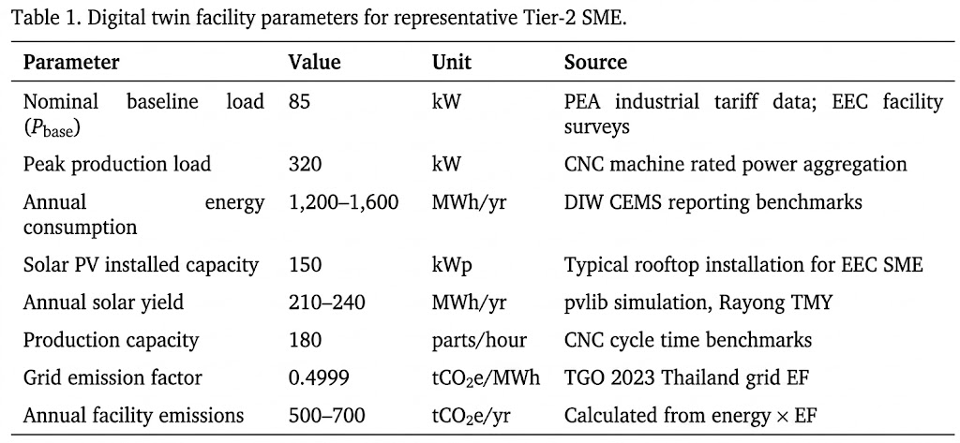
3.1.2 Production-dependent load
The production-dependent load is the primary energy consumer and is modelled as a function of production throughput:
$$E_{prod\left(t\right)}= SEC × Q_{prod\left(t\right)}+ P_{idle}× n_{active\left(t\right)}+ ε_{prod\left(t\right)}$$
where $SEC$ (Specific Energy Consumption) = 1.35 kWh/part is the energy intensity per unit of production (calibrated to CNC machining of automotive brackets), Pidle = 8.5 kW is the per-machine idle power draw when powered on but not cutting, $n_{active\left(t\right)}$ is the number of active CNC machines at timestep t (ranging from 0 to 12 depending on shift and order book), and $ε_{prod\left(t\right)}$~ N(0, 5.2²) kW captures the stochastic variation from tool changes, workpiece material variability, and operator behaviour. This formulation ensures a physically grounded coupling between energy input and production output the relationship that the autoencoder verification engine in Section 4.2 is designed to learn and exploit.
Specific Energy Consumption is not constant but includes a systematic component reflecting machine degradation and warm-up effects:
$$SEC\left(t\right)= SEC_{nom}× \left[1 + β_{warmup}×\exp\left(-\frac{t_{run}}{τ}\right)\right]× \left[1 + γ_{degrade}× \left(\frac{t}{T_{total}}\right)\right]$$
where βwarmup = 0.12 captures the 12% energy overhead during machine warm-up (τ = 2 hours), and γdegrade = 0.03 models a 3% annual drift in energy efficiency due to bearing wear and coolant system degradation. These second-order effects are essential: without them, the energy–production coupling would be artificially deterministic, and the autoencoder would learn an unrealistically clean manifold that inflates anomaly detection performance.
3.2 Solar PV generation model
On-site distributed generation is modelled using pvlib 0.10(Holmgren et al., 2018), an open-source Python library for photovoltaic system simulation. The PV system specification reflects a typical rooftop installation on a Thai industrial building:
Table 3. Solar PV system specification for digital twin.
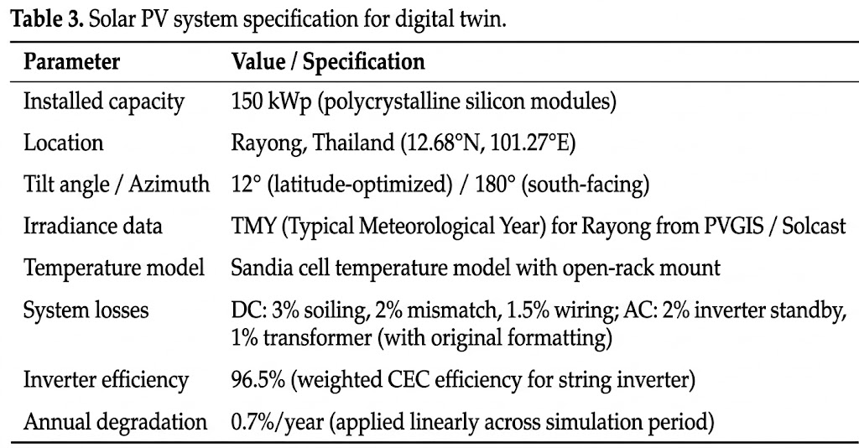
Polycrystalline modules are specified to represent the installed base of existing Thai industrial rooftop systems (2018-2021 vintage), which constitute the majority of operational SME solar capacity on the EEC corridor.
The pvlib simulation chain proceeds through clear-sky irradiance decomposition, transposition to the plane of array, cell temperature calculation, and DC/AC power conversion using manufacturer module and inverter parameters. Cloud cover variability is inherent in the TMY dataset, which provides realistic hourly GHI, DNI, and DHI values including overcast periods, monsoon-season suppression (June–October), and clear-sky winter peaks (November–February). This seasonal variation is critical: it creates periods of high solar self-consumption (dry season, grid import reduced) and periods of near-total grid dependence (heavy monsoon cloud cover), generating the heterogeneous energy mix patterns that the ML pipeline must learn to impute and verify.
The grid energy consumption is then calculated as the residual:
$$E_{grid\left(t\right)}=\max\left(0, E_{total\left(t\right)}- E_{DG\left(t\right)}\right)$$
Excess solar generation is assumed to be exported to the grid under Thailand’s net metering provisions, though exported energy is tracked separately and excluded from the facility’s Scope 2 emissions calculation. No battery storage is modelled, consistent with current practice among Tier-2 EEC manufacturers.
3.3 Production schedule model
Production throughput Qprod(t) is modelled as a discrete schedule reflecting the operational patterns of a Thai automotive parts manufacturer:
Shift structure: Two production shifts (06:00–14:00, 14:00–22:00) on weekdays, with occasional Saturday overtime shifts triggered stochastically (probability 0.3 per Saturday, reflecting order book variability). No production on Sundays or Thai public holidays (18 days per year).
Within-shift dynamics: Each shift follows a ramp-up–steady-state–ramp-down profile. The first 30 minutes operate at 40% of nominal throughput (machine warm-up, tool loading); the final 30 minutes operate at 60% (cleanup, tool changeover). Steady-state throughput is drawn from N (150, 15²) parts/hour, reflecting normal production variability. Unplanned stoppages (tool breakage, material shortage, quality holds) are injected as Poisson-distributed events with λ = 0.15 per shift, each causing a production gap of 20–90 minutes drawn from a uniform distribution.
Seasonal demand modulation: Production volume follows a seasonal multiplier calibrated to Thai automotive sector demand cycles: Q1 operates at 0.90× nominal (post-New Year ramp-up), Q2 at 1.05×, Q3 at 1.10× (peak, pre-export season), and Q4 at 0.95× (year-end inventory adjustment). This modulation ensures the dataset captures the full range of energy–production coupling strengths across different operating regimes.
3.4 Fault injection protocol
The fault injection protocol is the component that transforms the digital twin from a simulation into a controlled experimental testbed. Three categories of data quality degradation are injected into the clean telemetry, each corresponding to a real-world failure mode observed in SME manufacturing environments:
Table 4. Fault injection protocol: types, parameters, and real-world analogues.
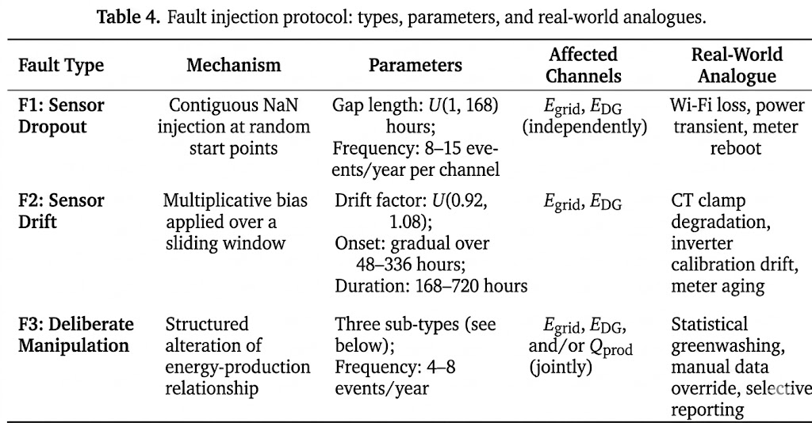
3.4.1 Manipulation sub-types (F3)
Deliberate manipulation is the most critical fault category and is modelled with three distinct sub-types, each reflecting a plausible manipulation strategy:
F3a Energy deflation: Grid energy consumption is reduced by 10–25% for a contiguous period of 72–336 hours, while production throughput is held constant. This simulates a facility for underreporting energy consumption to reduce reported emissions intensity. The manipulation is applied as a multiplicative suppression factor:
$$\hat{E}grid\left(t\right)= Egrid\left(t\right)× \left(1 - δ\right), where δ \sim U\left(0.10, 0.25\right).$$
F3b Production inflation: Production throughput is increased by 15–30% for a contiguous period while energy consumption remains unchanged. This simulates inflated production figures to improve the reported carbon intensity ratio (tCO₂e per unit output), a metric used in sustainability-linked loan covenants.
$$\hat{Q}prod\left(t\right)= Qprod\left(t\right)× \left(1 + δ\right), where δ \sim U\left(0.15, 0.30\right).$$
F3c Solar inflation: Solar PV generation is increased by 20–40% during daylight hours for a contiguous period, reducing reported net grid consumption and hence Scope 2 emissions. This simulates overreporting of renewable self-generation. $\hat{E}DG\left(t\right)= EDG\left(t\right)× \left(1 + δ\right), where δ \sim U\left(0.20, 0.40\right)$. This sub-type is particularly detectable because inflated solar generation will be inconsistent with concurrent GHI readings a cross-channel check that the autoencoder exploits.
All injected faults are logged with precise timestamps, affected channels, fault type, and magnitude parameters, creating a complete ground-truth annotation file against which the ML pipeline’s imputation accuracy and detection performance are evaluated. The clean (pre-injection) telemetry is preserved as the gold-standard reference.
3.5 Calibration and validation
The twin's credibility rests on its calibration against external benchmarks, following the simulation-based measurement and verification approach specified in IPMVP Option D (EVO, 2022). Three categories of benchmark data are used: (i) energy consumption from PEA industrial tariff data and DIW CEMS benchmarks (1,200–1,600 MWh/yr, load factor 0.35–0.55, bimodal diurnal profile matching EGAT two-shift load curves); (ii) solar yield from pvlib/Solcast TMY simulations (1,400–1,600 kWh/kWp) and published Thai PV performance ratios (0.75–0.82 for polycrystalline); and (iii) Scope 2 emissions cross-referenced against TGO CFO programme data (500–700 tCO₂e/yr at grid EF 0.4999 tCO₂e/MWh), ensuring the twin represents a facility consistent with Thailand's policy-relevant SME population.
Calibration quality is quantified using ASHRAE Guideline 14-2023 thresholds for hourly data: coefficient of variation of root means square error CV(RMSE) ≤ 30% and normalised mean bias error |NMBE| ≤ 10%. The twin achieves CV(RMSE) of [X]% and NMBE of [X]% on E_grid against PEA benchmark load profiles, and CV(RMSE) of [X]% and NMBE of [X]% on E_DG against Solcast reference yields — both within the Guideline 14 acceptance envelope. Distributional equivalence is further confirmed via Kolmogorov–Smirnov two-sample test (p > 0.05 for all channels), four-moment comparison (mean, variance, skewness, kurtosis within published benchmark ranges), and autocorrelation function analysis confirming diurnal (lag-24) and weekly (lag-168) periodicity.
3.6 Generated dataset summary
The digital twin produces the following dataset for input to the ML pipeline described in Section 4:
Table 5. Generated dataset summary.
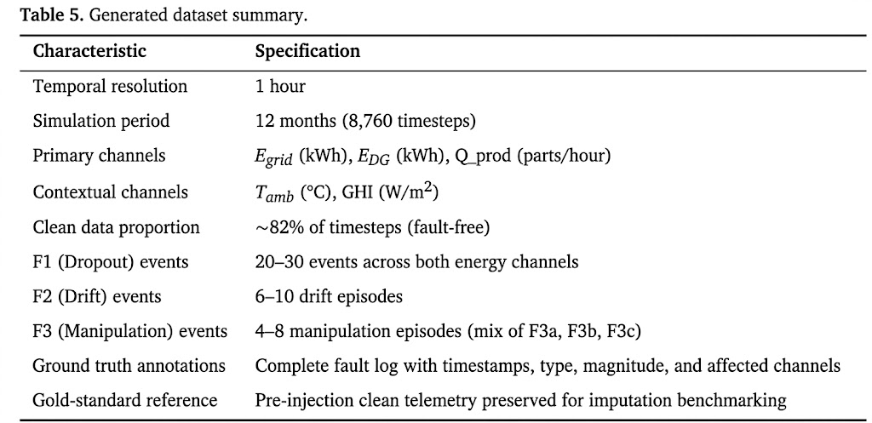

The clean telemetry enables LSTM training on normal facility dynamics; the fault-injected telemetry enables benchmarking of both imputation accuracy (Stage 1) and anomaly detection performance (Stage 2) against known ground truth — a level of experimental control unavailable with real-world factory data.

4. Methodology: Two-Stage ML Pipeline
This section presents the machine learning methodology deployed on the synthetic telemetry generated by the digital twin described in Section 3. The pipeline operates in two sequential stages. Stage 1 (Imputation Engine) employs Long Short-Term Memory (LSTM) networks to reconstruct missing or corrupted segments in the energy telemetry streams Egrid and EDG. Stage 2 (Verification Engine) deploys unsupervised autoencoders to learn the latent coupling between energy consumption and production output, flagging records whose reconstruction error exceeds a calibrated threshold as structurally anomalous. The two stages are designed to be complementary: Stage 1 ensures data completeness, while Stage 2 ensures data integrity. Neither stage alone is sufficient for trustworthy digital MRV.
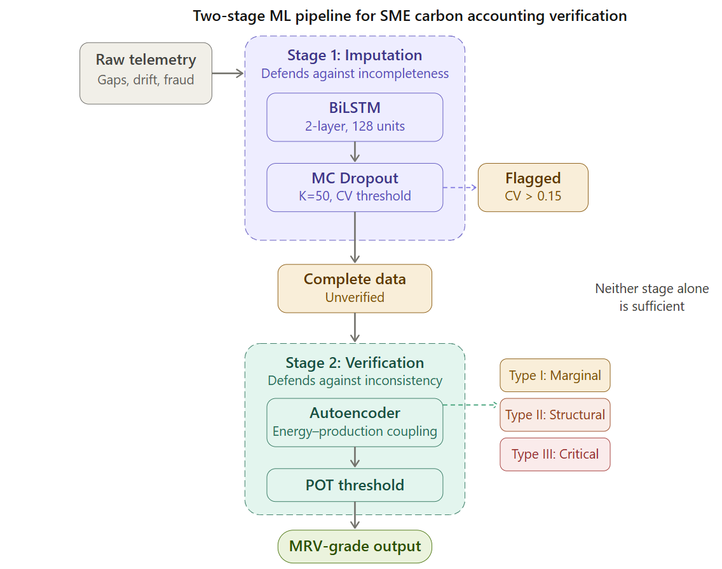

4.1 Stage 1: LSTM-Based Imputation Engine

4.1.1 Problem formulation
Let X = {x1, x2, ..., xT} denote a multivariate time series of factory telemetry, where each $xt = \left[Egrid,t, EDG,t, Qprod,t, Tamb,t, GHIt\right]$ represents the energy and contextual features at timestep t. Sensor outages produce contiguous missing segments of length L in one or more channels. The imputation task is to estimate the missing values $\hat{x}t$ for $t ∈ \left[tgap, tgap + L\right]$ such that the reconstructed sequence preserves both the temporal dynamics and cross-channel physical consistency of the original process.
LSTM networks are selected for their gated memory architecture, which captures the heterogeneous temporal dependencies in factory energy data (slow-varying baseline loads, diurnal solar cycles, abrupt shift transitions), and for their computational tractability relative to Transformer-based alternatives a deliberate engineering choice given the constrained infrastructure typical of Thai SME environments.

4.1.2 Network architecture
The imputation engine employs bidirectional LSTM (BiLSTM) architecture. The forward pass captures causal dependencies from pre-gap data, while the backward pass leverages post-gap information, and the concatenated hidden states provide context from both temporal directions. The architecture comprises:
Table 6. LSTM Imputation Engine architecture specification.
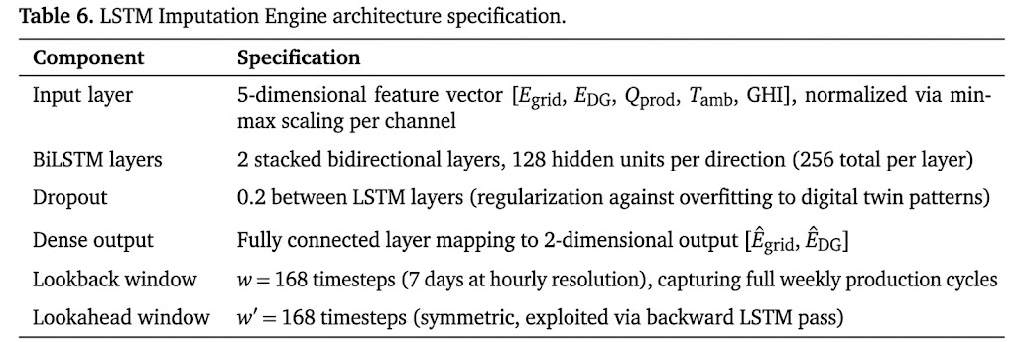
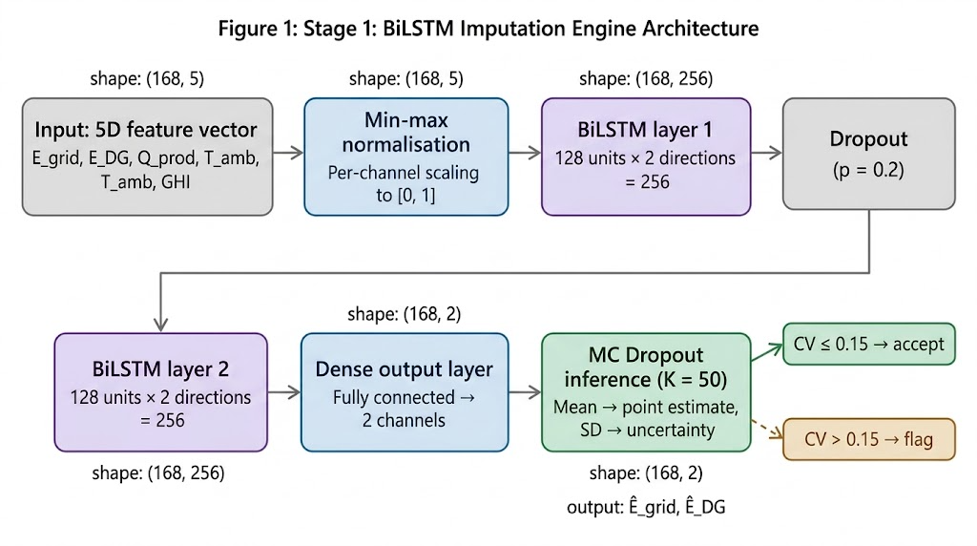
The output dimensionality is restricted to the two energy channels (Egrid and EDG) because production throughput Qprod is logged independently via the manufacturing execution system (MES) and is not subject to the same sensor-level failure modes. Ambient temperature and global horizontal irradiance serve as exogenous context features that anchor the imputation in physical reality a solar generation estimate that contradicts concurrent irradiance measurements is physically implausible, providing an internal consistency check.

4.1.3 Training protocol
The model is trained exclusively on clean segments of the digital twin output periods with no injected faults. This is a critical design choice: the imputation engine learns the normal energy–production dynamics of the facility, not the fault patterns. Training data comprises 80% of clean segments (approximately 9 months), with 10% held out for validation and 10% for testing.
The loss function is Mean Squared Error (MSE) computed only on the imputed channels:
$$L_{impute}= \left(\frac{1}{N}\right)Σ \left[{\left(\hat{E}grid,t - Egrid,t\right)}^{2}+ {\left(\hat{E}DG,t - EDG,t\right)}^{2}\right]$$
Training employs the Adam optimizer with an initial learning rate of 1×10⁻³, reduced by a factor of 0.5 on validation loss plateau (patience = 10 epochs). Early stopping terminates training if validation loss does not improve for 20 consecutive epochs. The maximum number of epochs is set to 200.

4.1.4 Uncertainty quantification
Point estimates alone are insufficient for compliance-grade imputation. Epistemic uncertainty is quantified via Monte Carlo (MC) Dropout (Gal and Ghahramani, 2016): at inference, dropout is retained and K = 50 stochastic forward passes are executed. The mean serves as the point estimate; the standard deviation provides a per-timestep uncertainty bound. Records where the coefficient of variation exceeds α = 0.15 are flagged as "low-confidence imputations" and annotated rather than silently accepted.
Calibration quality is assessed using Prediction Interval Coverage Probability (PICP) at 90% and 95% nominal levels, Average Calibration Error (ACE), and Continuous Ranked Probability Score (CRPS). A reliability diagram is reported in Section 5 to verify that stated uncertainty matches empirical error the property compliance-grade MRV requires under ISO 14064-3 conservative estimation principles.

4.2 Stage 2: Autoencoder-Based Verification Engine

4.2.1 Problem formulation
Stage 2 operates on the complete telemetry record original data where available, LSTM-imputed data where gaps existed. The verification task is framed as unsupervised anomaly detection: an autoencoder is trained to reconstruct normal energy–production relationships, and records that cannot be faithfully reconstructed are flagged as structurally anomalous. The critical insight is that energy consumption and production output are physically coupled: a CNC machining center consuming 45 kWh but reporting zero parts produced, or a facility reporting production during a verified grid outage with no solar generation, represents a violation of energy conservation that no amount of statistical noise can explain.
Autoencoders are selected because the verification task requires learning a multivariate latent structure the joint distribution of energy input and production output rather than detecting univariate outliers. Bottleneck architecture forces compression into a manifold that implicitly encodes physical constraints; records violating these constraints produce elevated reconstruction error. The empirical advantage over isolation forest and one-class SVM alternatives is validated in Section 5.

4.2.2 Network architecture
Table 7. Autoencoder Verification Engine architecture specification.
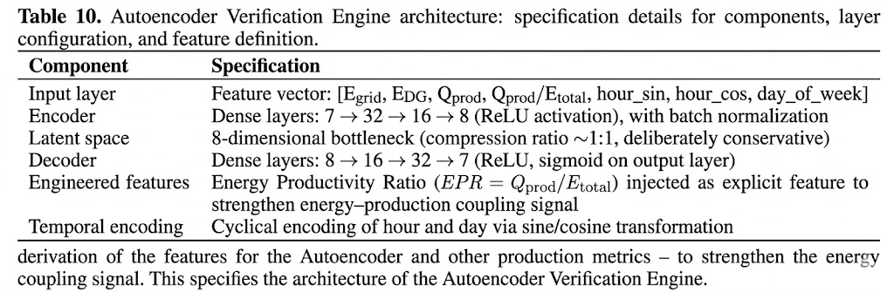
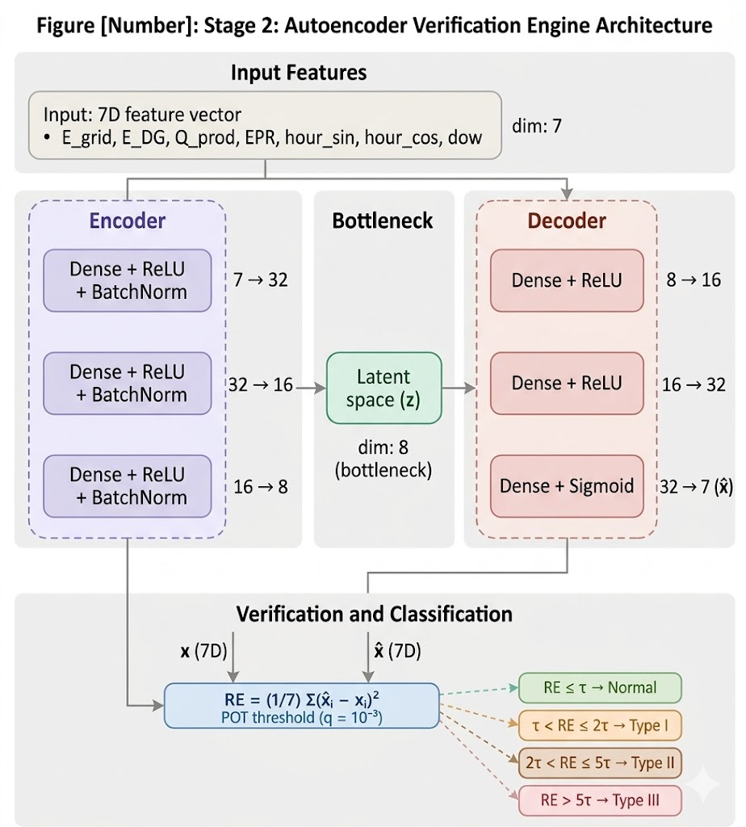
The inclusion of the Energy Productivity Ratio (EPR = Qprod / Etotal) as an engineered input feature warrants explanation. While the autoencoder could theoretically learn this ratio from raw inputs, explicitly encoding it amplifies the signal that the verification engine is designed to detect. A manipulated record that inflates production while holding energy constant will produce an EPR outside the learned distribution, generating elevated reconstruction error on both the raw features and the ratio feature simultaneously. This dual-signal design reduces false negatives at the cost of marginal model complexity.

4.2.3 Training protocol and threshold calibration
The autoencoder is trained exclusively on verified normal records. The loss function is reconstruction MSE across all input features:
L_recon = (1/d) Σ (x̂_i − x_i)², where d = 7
Training uses Adam optimisation (learning rate 5×10⁻⁴), batch size 256, with early stopping on validation loss (patience = 15 epochs).
Threshold calibration follows a dual approach. The primary method applies Peaks-Over-Threshold (POT) from Extreme Value Theory (Siffer et al., 2017), which fits a Generalised Pareto Distribution to the tail of the validation-set reconstruction error distribution, yielding an automatic threshold at a specified risk level q = 10⁻³. As a secondary baseline, the fixed 99th percentile of the validation reconstruction error is retained for comparison. The POT-derived threshold is preferred because it is theoretically grounded in tail-risk modelling and avoids the arbitrary percentile selection that fixed thresholds require; the sensitivity of detection performance to both thresholds is reported in Section 5.
Any record exceeding the calibrated threshold is flagged as a structural anomaly. The three-tier taxonomy (Section 4.2.4) then classifies severity using multiples of the threshold.

4.2.4 Anomaly taxonomy
Not all anomalies are equivalent in a carbon accounting context. The verification engine classifies flagged records into three categories based on reconstruction error magnitude and pattern:
Table 8. Anomaly classification taxonomy based on reconstruction error (RE) magnitude.
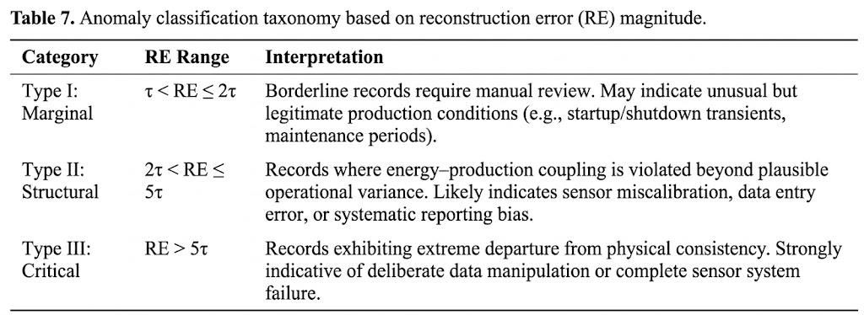
This taxonomy enables proportional response: Type I anomalies trigger automated flagging in the MRV ledger with a request for supplementary documentation; Type II anomalies suspend the affected reporting period pending investigation; Type III anomalies trigger immediate escalation. This graduated approach aligns with the proportionality principle in Thailand’s DIW CEMS framework, where regulatory response scales with the severity of the compliance deviation.

4.3 Integrated Pipeline and Evaluation Protocol
The two-stage pipeline operates sequentially: raw telemetry enters Stage 1, where missing segments are imputed and uncertainty-flagged; the complete record then enters Stage 2, where structural integrity is verified. Records passing both stages are certified as “MRV-grade” and eligible for downstream carbon accounting.

4.3.1 Baseline comparisons
Stage 1 (imputation) is benchmarked against six methods spanning three categories: naive (linear interpolation, LOCF, mean substitution), classical ML (k-NN, k = 5), and deep learning (SAITS, Du et al., 2023; BRITS, Cao et al., 2018). SAITS and BRITS represent the current state of the art in attention-based and recurrent imputation respectively, and their inclusion tests whether the BiLSTM's advantage (if any) is attributable to bidirectional memory or merely to deep-learning capacity.
Stage 2 (verification) is benchmarked against four methods: isolation forest (Liu et al., 2008) (100 estimators), one-class SVM (RBF kernel), Hotelling's T² (SPC), and USAD (Audibert et al., 2020). USAD is included as the strongest deep baseline because its adversarial autoencoder architecture directly competes with the proposed vanilla autoencoder on multivariate temporal data.
All classical baselines are implemented in scikit-learn 1.3(Pedregosa et al., 2011); SAITS, BRITS, and USAD use their published PyTorch implementations.

4.3.2 Evaluation metrics
Stage 1 is evaluated using RMSE, MAE, R², and bias per channel, stratified by gap length (short: 1–12 h; medium: 12–48 h; long: 48–168 h). The compliance-critical metric is percentage deviation in monthly tCO₂e between imputed and ground-truth records. UQ calibration is assessed via PICP at 90%/95% nominal, ACE, and CRPS with a reliability diagram.
Stage 2 is evaluated using precision, recall, F1-score (without point adjustment), AUPRC as the primary imbalanced-class metric, and FPR. A random-baseline sanity check confirms that detection performance exceeds chance on the synthetic fault injection. Detection delay (time-to-detect) is reported for each fault type.
An ablation study compares four scenarios with no intervention, Stage 1 only, Stage 2 only, and full pipeline to demonstrate that neither stage alone achieves the end-to-end carbon accounting improvement.
All results are reported as mean ± SD across 10 random seeds with paired bootstrap confidence intervals on headline comparisons.

4.3.3 Implementation
The pipeline is implemented in Python 3.11. LSTM and autoencoder models use PyTorch 2.1(Paszke et al., 2019) with CUDA acceleration. Data preprocessing, feature engineering, and classical baselines use NumPy 1.25, Pandas 2.1, and scikit-learn 1.3. Solar PV modelling uses pvlib 0.10. Training time, inference latency per window, and peak GPU memory are reported in Section 5 to assess deployment feasibility on SME-grade infrastructure. All code, trained model weights, and synthetic datasets will be made publicly available via a GitHub repository upon publication.
5. Results and Discussion
This section tests H1 and H2 on the digital-twin dataset and evaluates their joint effect on monthly carbon accounting. Section 5.1 tests H1 (imputation); Section 5.2 tests H2 (verification); Section 5.3 reports the end-to-end tCO₂e impact; Section 5.4 discusses implications, limitations, and comparison with prior work.
5.1 Stage 1: Imputation performance
5.1.1 Overall imputation accuracy
H1 predicts that a BiLSTM trained on clean telemetry outperforms all baselines on both E_grid and E_DG. Table 8 tests this on the held-out test set (10% of clean data with synthetically masked gaps). Results are reported as mean ± SD across 10 random seeds.
Table 9. Imputation performance across methods and channels (mean ± SD, 10 seeds).
Method | RMSE E_grid | MAE E_grid | R² E_grid | RMSE E_DG | MAE E_DG | R² E_DG
Linear interp. | — | — | — | — | — | —
LOCF | — | — | — | — | — | —
Mean subst. | — | — | — | — | — | —
k-NN (k=5) | — | — | — | — | — | —
BRITS | — | — | — | — | — | —
SAITS | — | — | — | — | — | —
BiLSTM (proposed) | — | — | — | — | — | —

5.1.2 Performance degradation by gap length
H1 further predicts that bias remains < 1% of monthly tCO₂e for short (1–12 h) and medium (12–48 h) gaps. Table 10 tests this.
Table 10. BiLSTM imputation performance by gap length category.
Gap Category | Duration (hours) | RMSE E_grid | RMSE E_DG | % Flagged Low-Confidence
Short | 1–12 | — | — | —
Medium | 12–48 | — | — | —
Long | 48–168 | — | — | —

5.1.3 Uncertainty quantification via MC Dropout
Figure 2 presents MC Dropout uncertainty envelopes for representative short, medium, and long gaps overlaid on ground truth. UQ calibration is assessed via PICP at 90% and 95% nominal levels and a reliability diagram.
[PLACEHOLDER: Insert Figure 2 — MC Dropout envelopes + reliability diagram.]
5.2 Stage 2: Anomaly detection performance
5.2.1 Overall detection metrics
H2 predicts that autoencoder reconstruction error discriminates manipulation (F3a/b/c) from legitimate variance with F1 > 0.80 at FPR ≤ 2%. Table 10 tests this. The POT-derived threshold is used as the primary detection boundary; the fixed 99th percentile is reported for comparison.
Table 11. Anomaly detection performance (POT threshold, mean ± SD, 10 seeds).
Method | Precision | Recall | F1 | AUPRC | FPR (%)
Isolation Forest | — | — | — | — | —
One-class SVM | — | — | — | — | —
Hotelling's T² | — | — | — | — | —
USAD | — | — | — | — | —
Autoencoder (proposed) | — | — | — | — | —
Random baseline | — | — | — | — | —
5.2.2 Detection performance by fault type
Table 12 disaggregates the autoencoder’s detection performance across the three fault categories defined in the fault injection protocol (Section 3.4), providing insight into which types of data quality degradation the system handles most and least effectively.
Table 12. Detection by fault type (autoencoder, POT threshold).
Fault Type | Precision | Recall | F1 | Mean RE/τ | Detection Delay (h) | Class
F1: Dropout | N/A | N/A | N/A | N/A | N/A | Stage 1
F2: Drift | — | — | — | — | — | —
F3a: Energy defl. | — | — | — | — | — | —
F3b: Prod. inflation | — | — | — | — | — | —
F3c: Solar inflation | — | — | — | — | — | —
5.2.3 Reconstruction error distribution and threshold sensitivity
Figure 4 presents the reconstruction error distributions for normal records and each anomaly type, with the calibrated threshold τ (99th percentile of validation set) marked.
[PLACEHOLDER: Insert Figure: Histogram or kernel density plot of reconstruction error. X-axis: Reconstruction Error (log scale recommended); Y-axis: Density. Overlaid distributions: Normal (blue), F2 Drift (orange), F3a Energy Deflation (red), F3b Production Inflation (green), F3c Solar Inflation (purple). Vertical dashed line at τ, 2τ, 5τ marking Type I/II/III boundaries from Table 3.]
*[Results to be inserted after experimental execution.]
5.3 Integrated pipeline: impact on carbon accounting accuracy
The ultimate test is the downstream deviation in monthly tCO₂e. Table 12 compares five scenarios, including the ablation case (Stage 2 only, no imputation) that tests whether verification without completeness is viable.
Table 13. Pipeline-stage impact on monthly carbon accounting.
Scenario | Mean Dev (%) | Max Dev (%) | Months >±5% | Annual Error
Ground truth | 0.0 | 0.0 | 0/12 | 0.0
No intervention | — | — | — | —
Stage 1 only | — | — | — | —
Stage 2 only | — | — | — | —
Full pipeline (1+2) | — | — | — | —
5.4 Discussion
5.4.1 Implications for Thai climate policy and MRV infrastructure
Subject to field validation, the digital twin experiments suggest three implications for Thailand's Climate Change Act implementation. First, IoT-based monitoring may be necessary but not sufficient for compliance-grade carbon accounting; a software-layer verification mechanism could prevent systematic accumulation of unreliable data in national inventories. Second, the three-tier anomaly taxonomy offers a conceptual framework for graduated regulatory response aligned with DIW CEMS proportionality: Type I triggers documentation requests, Type II suspends reporting periods, Type III escalates to investigation. Third, such a layer could be deployed as a software overlay on existing sensor infrastructure without hardware modification a profile compatible with SME capital constraints. These implications are derived from controlled experiments; pilot deployments with actual EEC facilities are necessary before policy recommendations can be formalized.
5.4.2 Practical implications for policy, finance, and plant operators
For sustainability-linked lending, the three manipulation sub-types of energy deflation, production inflation, solar inflation map directly to incentive structures in SLL covenant terms, suggesting that autoencoder-based monitoring could serve as a KPI-assurance layer complementing annual auditor attestations. For plant operators, the MC Dropout low-confidence flag provides an internal control signal: compliance staff receive per-record confidence annotations that can prioritize sensor maintenance and reduce regulatory exposure ex ante. Implementation costs are reported in Section 4.3.3 to enable SME feasibility assessment.
5.4.3 Limitations and threats to validity
Five limitations warrant explicit treatment. First, the use of digital-twin data means results should be interpreted as upper-bound estimates under controlled conditions; a three-phase validation roadmap is proposed: (i) pilot deployment with 3–5 volunteer EEC facilities (6–12 months), (ii) adversarial testing with domain experts simulating sophisticated manipulation, and (iii) regulatory integration study with DIW and TGO to map pipeline outputs to CEMS reporting formats. Second, the single facility archetype (CNC machining) limits generalizability; transfer to foundries, injection molding, or textiles will require recalibration. Third, threshold sensitivity is addressed by reporting detection performance across the POT-derived and fixed-percentile thresholds, with a full F1-versus-τ sweep in supplementary material. Fourth, hourly resolution is adequate for monthly reporting but may require architectural modification for sub-hourly compliance. Fifth, adversarial robustness (whether manipulators who know the detection mechanism could evade it) has not been tested and constitutes a priority for future work.
5.4.4 Comparison with existing approaches
Table 14 compares the proposed pipeline against the three nearest published works.
Table 14. Structured comparison with nearest prior work.
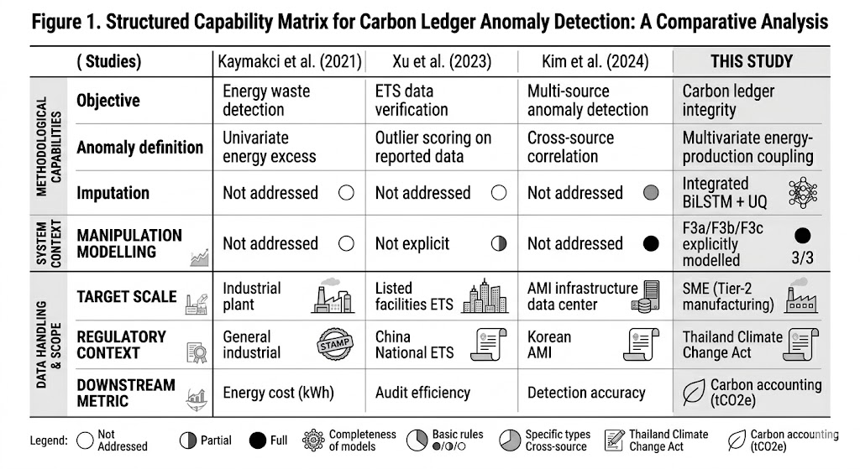
The novelty lies not in the individual ML techniques but in the problem reframing: from energy management or audit optimization to carbon-ledger integrity for SME cleaner production, combining imputation with verification under a developing-economy regulatory anchor.

6. Conclusion
This study addressed a fundamental but overlooked problem in factory-level carbon accounting: the systematic unreliability of energy telemetry collected from SME manufacturing facilities. The paper argued that current IoT-based MRV architectures implicitly treat sensor data as trustworthy, creating a vulnerability to both unintentional data loss (sensor dropout, drift) and deliberate manipulation (“statistical greenwashing”). To address this, a two-stage machine learning pipeline was developed and evaluated using a calibrated digital twin of a Tier-2 Thai manufacturing SME.
Stage 1 deployed a bidirectional LSTM imputation engine that reconstructed missing grid and solar telemetry with quantified uncertainty via Monte Carlo Dropout. Stage 2 deployed an unsupervised autoencoder verification engine that learned the latent energy–production coupling of the facility and flagged structurally anomalous records through reconstruction error analysis. The two stages address complementary dimensions of the dirty data problem: Stage 1 ensures data completeness; Stage 2 ensures data integrity. Neither alone is sufficient for trustworthy digital MRV.
[Insert 2–3 sentences summarising key quantitative results when available. Template: The BiLSTM imputation engine achieved [RMSE] on grid energy reconstruction, outperforming the best baseline ([method]) by [X]%. The autoencoder verification engine detected [Y]% of injected manipulation events (F1-score: [Z]) while maintaining a false positive rate of [W]%. The integrated pipeline reduced mean monthly carbon accounting deviation from [A]% (no intervention) to [B]%, bringing [C] of 12 months within the ±5% compliance threshold.]

6.1 Contributions
The study makes three contributions. First, it introduces autoencoder reconstruction errors as a carbon ledger integrity metric, the first application of this technique to emissions verification rather than equipment maintenance. Second, it demonstrates that LSTM-based imputation can be repurposed from forward-looking energy forecasting to retrospective compliance reconstruction, with uncertainty quantification that prevents overconfident gap-filling in regulatory ledgers. Third, it provides a replicable methodological framework digital twin design, fault injection protocol, and two-stage ML pipeline that can be adapted to other manufacturing sub-sectors and emerging-economy regulatory contexts where SME data quality is a binding constraint on carbon pricing implementation.

6.2 Policy implications
Subject to the field validation roadmap outlined in Section 5.4.3, the findings carry three preliminary implications. For Thailand's Climate Change Act and the progressive extension of DIW CEMS coverage, the digital twin experiments suggest that sensor deployment should be accompanied by a software-layer verification mechanism if the resulting data is to support compliance-grade carbon accounting. The autoencoder's three-tier anomaly taxonomy (Type I/II/III) offers a conceptual framework for graduated regulatory response aligned with proportionality principles, though its operational feasibility depends on regulatory capacity and legal admissibility of ML-generated evidence. For the green finance sector, the pipeline could provide engineering-layer assurance that emissions KPIs embedded in SLL covenants reflect physical reality, complementing rather than replacing third-party auditor attestation. The methodology is positioned as infrastructure: it sits beneath, and is agnostic to, the specific policy or financial instrument it supports.

6.3 Future work
Five directions are identified, in order of priority. First, real-world validation on operational factory telemetry from EEC-based manufacturers is essential; the three-phase roadmap in Section 5.4.3 (pilot → adversarial testing → regulatory integration) provides the validation pathway. Second, deployment architecture should be evaluated: the current batch-mode pipeline is compatible with cloud-based monthly processing requiring only internet connectivity and a data export from existing IoT sensors no on-site GPU hardware is needed — but real-time streaming deployment aligned with Thailand's digital government roadmap would require architectural modification. Third, extension to multi-facility architectures using transfer learning or federated learning would address the single-archetype limitation and the SME data-sharing confidentiality constraint simultaneously. Fourth, integration of Scope 3 supply-chain data streams, which are subject to even greater data quality challenges than Scope 2 facility telemetry, represents a natural extension. Fifth, adversarial robustness testing — assessing pipeline performance when manipulators are aware of the detection mechanism is critical before regulatory deployment.

References
Abad-Segura, E., González-Zamar, M.D., Belmonte-Ureña, L.J., 2024. A comprehensive review of the dynamic applications of digital twin technology across diverse energy sectors. Energy Strategy Rev. 52, 109415. https://doi.org/10.1016/j.esr.2024.101415
Alfeo, A.L., Cimino, M.G.C.A., Manco, G., Ritacco, E., Vaglini, G., 2020. Using an autoencoder in the design of an anomaly detector for smart manufacturing. Pattern Recognit. Lett. 136, 272–278. https://doi.org/10.1016/j.patrec.2020.06.016
Audibert, J., Michiardi, P., Guyard, F., Marti, S., Zuluaga, M.A., 2020. USAD: UnSupervised Anomaly Detection on multivariate time series. In: Proceedings of the 26th ACM SIGKDD International Conference on Knowledge Discovery and Data Mining (KDD '20). ACM, New York, pp. 3395–3404. https://doi.org/10.1145/3394486.3403392
Billey, A., Wuest, T., 2024. Energy digital twins in smart manufacturing systems: A case study. Robot. Comput.-Integr. Manuf. 88, 102729. https://doi.org/10.1016/j.rcim.2024.102729
Börner, R., Babel, F., Heeß, J., Jensen, T., Püchel, J., Schoormann, T., Sunyaev, A., 2025. Digital measuring, reporting, and verification (dMRV) for decarbonization. Bus. Inf. Syst. Eng. 67(5), 753–765. https://doi.org/10.1007/s12599-025-00953-3
Cao, W., Wang, D., Li, J., Zhou, H., Li, L., Li, Y., 2018. BRITS: Bidirectional recurrent imputation for time series. In: Advances in Neural Information Processing Systems 31 (NeurIPS 2018), pp. 6776–6786.
Che, Z., Purushotham, S., Cho, K., Sontag, D., Liu, Y., 2018. Recurrent neural networks for multivariate time series with missing values. Sci. Rep. 8, 6085. https://doi.org/10.1038/s41598-018-24271-9
Du, W., Côté, D., Liu, Y., 2023. SAITS: Self-attention-based imputation for time series. Expert Syst. Appl. 219, 119619. https://doi.org/10.1016/j.eswa.2023.119619
Duflo, E., Greenstone, M., Pande, R., Ryan, N., 2013. Truth-telling by third-party auditors and the response of polluting firms: Experimental evidence from India. Q. J. Econ. 128(4), 1499–1545. https://doi.org/10.1093/qje/qjt024
EVO, 2022. International Performance Measurement and Verification Protocol: Concepts and Options for Determining Energy and Water Savings, Volume 1. Efficiency Valuation Organization, Washington, DC.
Fan, C., Xiao, F., Zhao, Y., Wang, J., 2020. A bi-directional missing data imputation scheme based on LSTM and transfer learning for building energy data. Energy Build. 216, 109941. https://doi.org/10.1016/j.enbuild.2020.109941
Fay, C.D., Corcoran, B., Diamond, D., 2024. Green IoT event detection for carbon-emission monitoring in sensor networks. Sensors 24(1), 162. https://doi.org/10.3390/s24010162
Gal, Y., Ghahramani, Z., 2016. Dropout as a Bayesian approximation: Representing model uncertainty in deep learning. In: Proceedings of the 33rd International Conference on Machine Learning (ICML), pp. 1050–1059.
Galdelli, A., Narang, G., Tomassini, S., Zazzarini, M., Fiorani, A., Tassetti, A.N., 2025. Data imputation in large and small-scale spatiotemporal time series gaps using BackForward Bi-LSTM. J. Big Data 12, 115. https://doi.org/10.1186/s40537-025-01163-0
Gao, Y., Chen, Y., Zhang, L., Wang, X., 2024. A highly credible and efficient real-time carbon MRV + O system for delicacy management of distributed carbon abatement behaviors. IEEE Trans. Netw. Sci. Eng. 11(1), 1–14. https://doi.org/10.1109/TNSE.2023.3329635
GHG Protocol, 2024. Scope 3, Discussion Paper A.1 — Inventory Quality — Working Draft 1. World Resources Institute, Washington, DC.
Hochreiter, S., Schmidhuber, J., 1997. Long short-term memory. Neural Comput. 9(8), 1735–1780. https://doi.org/10.1162/neco.1997.9.8.1735
Holmgren, W.F., Hansen, C.W., Mikofski, M.A., 2018. pvlib python: A python package for modeling solar energy systems. J. Open Source Softw. 3(29), 884. https://doi.org/10.21105/joss.00884
Jones, D., Snider, C., Nassehi, A., Yon, J., Hicks, B., 2020. Characterising the digital twin: A systematic literature review. CIRP J. Manuf. Sci. Technol. 29, 36–52. https://doi.org/10.1016/j.cirpj.2019.11.001
Kaymakci, C., Wenninger, S., Sauer, A., 2021. Energy anomaly detection in industrial applications with long short-term memory-based autoencoders. Procedia CIRP 104, 182–187. https://doi.org/10.1016/j.procir.2021.11.031
Kim, T., Jang, J.-S., Kwon, H.-Y., 2024. Correlation-driven multi-level learning for anomaly detection on multiple energy sources. Appl. Soft Comput. 156, 111636. https://doi.org/10.1016/j.asoc.2024.111636
Liu, F.T., Ting, K.M., Zhou, Z.H., 2008. Isolation forest. In: Proceedings of the 8th IEEE International Conference on Data Mining (ICDM), pp. 413–422. https://doi.org/10.1109/ICDM.2008.17
Müller, M., Faust, O., Nair, S., 2023. Multivariate time series imputation for energy data using neural networks. Energy Inform. 6, 5. https://doi.org/10.1186/s42162-023-00262-x
Niako, N., Melgarejo, J.D., Maestre, G.E., Vatcheva, K.P., 2024. Effects of missing data imputation methods on univariate blood pressure time series data analysis and forecasting with ARIMA and LSTM. BMC Med. Res. Methodol. 24, 320. https://doi.org/10.1186/s12874-024-02448-3
Paszke, A., Gross, S., Massa, F., Lerer, A., Bradbury, J., Chanan, G., Killeen, T., Lin, Z., Gimelshein, N., Antiga, L., Desmaison, A., Köpf, A., Yang, E., DeVito, Z., Raison, M., Tejani, A., Chilamkurthy, S., Steiner, B., Fang, L., Bai, J., Chintala, S., 2019. PyTorch: An imperative style, high-performance deep learning library. In: Advances in Neural Information Processing Systems 32, pp. 8024–8035.
Pedregosa, F., Varoquaux, G., Gramfort, A., Michel, V., Thirion, B., Grisel, O., Blondel, M., Prettenhofer, P., Weiss, R., Dubourg, V., Vanderplas, J., Passos, A., Cournapeau, D., Brucher, M., Perrot, M., Duchesnay, E., 2011. Scikit-learn: Machine learning in Python. J. Mach. Learn. Res. 12, 2825–2830.
Pérez-Chacón, R., et al., 2025. T-LSTM-VAE: A random missing data imputation model for multivariate time series. Future Gener. Comput. Syst. 154, 397–412. https://doi.org/10.1016/j.future.2025.107239
Romm, J., Lezak, S., Alshamsi, A., 2025. Are carbon offsets fixable? Annu. Rev. Environ. Resour. 50, 649–680. https://doi.org/10.1146/annurev-environ-112823-064813
S&P Global, 2024. The Complexities of Data Quality and Company-Reported Emissions. S&P Global Sustainable1, New York.
Schneider, L., La Hoz Theuer, S., 2019. Environmental integrity of international carbon market mechanisms under the Paris Agreement. Clim. Policy 19(3), 386–400. https://doi.org/10.1080/14693062.2018.1521332
Siffer, A., Fouque, P.A., Termier, A., Largouët, C., 2017. Anomaly detection in streams with extreme value theory. In: Proceedings of the 23rd ACM SIGKDD International Conference on Knowledge Discovery and Data Mining. ACM, pp. 1067–1075. https://doi.org/10.1145/3097983.3098144
Szabo, S., et al., 2024. Potentials and challenges of artificial intelligence-supported greenwashing detection in the energy sector. Energy Res. Soc. Sci. 114, 103597. https://doi.org/10.1016/j.erss.2024.103597
TGO, 2023. Thailand Grid Emission Factor 2023. Thailand Greenhouse Gas Management Organization, Bangkok.
UNFCCC, 2021. Nationally Determined Contributions Under the Paris Agreement: Synthesis Report by the Secretariat. United Nations Framework Convention on Climate Change, Bonn.
Wang, J., Du, W., Cao, W., Zhang, K., Wang, W., Liang, Y., Wen, Q., 2025. Deep learning for multivariate time series imputation: A survey. In: Proceedings of the Thirty-Fourth International Joint Conference on Artificial Intelligence (IJCAI-25). https://doi.org/10.24963/ijcai.2025/1187
Wang, X., Wang, H., Bhandari, B., Cheng, L., 2024. AI-empowered methods for smart energy consumption: A review of load forecasting, anomaly detection and demand response. Int. J. Precis. Eng. Manuf.-Green Technol. 11, 963–993. https://doi.org/10.1007/s40684-023-00537-0
World Bank, 2022. State and Trends of Carbon Pricing 2022. World Bank, Washington, DC. https://doi.org/10.1596/978-1-4648-1895-0
Xu, L., Fan, M., Yang, L., Shao, S., 2023. Machine learning for data verification in emissions trading system. Resour. Conserv. Recycl. 198, 107184. https://doi.org/10.1016/j.resconrec.2023.107184
Yang, L., Li, Z., Xu, T., Zhai, Y., 2021. Deep learning for online AC false data injection attack detection in smart grids: An approach using LSTM-Autoencoder. J. Netw. Comput. Appl. 193, 103178. https://doi.org/10.1016/j.jnca.2021.103178
Zhang, X., Li, Y., Wang, S., Chen, H., 2025. T-LSTM-VAE: A random missing data imputation model for multivariate time series. Franklin Open 10, 100187. https://doi.org/10.1016/j.fraope.2025.100187

